244 Peachtree Street Jesup Ga. 31545
Phone: 912-427-5915
Fax: 912-427-5945

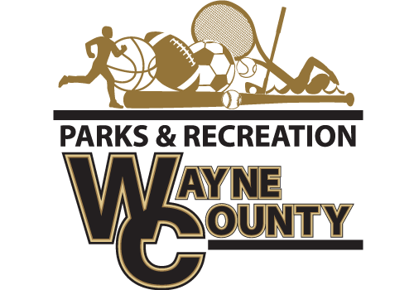
The Wayne County Recreation Department is accepting bids for 2018-2019 Basketball Jerseys.
Requirements
-Brand Alleson NBA Replica Jersey.
-Must be able to get all teams
-Must have all sizes available Youth to Adult XXL
Approximate Numbers for all leagues: 300
Coaches Shirt Requirement
Approximate Number for coaches/assistant: 50
-Augusta t Brand-shirt with team name on front
Bids must be submitted before 10:00 am on December 21, 2018. Bids will be opened at that time. Winning bids will be awarded before 5:00 pm on December 21, 2018. Delivery date on all uniforms must be by Monday, January 7, 2019.
Bids must be delivered to Wayne County Commissioner’s office at 341 E Walnut Street, Jesup, Georgia 31546 or mailed to PO Box 270, Jesup, Georgia 31598 Attn: Amanda Hannah, envelopes must be marked Wayne County Recreation “BID”. Wayne County reserves the right to reject any and all bids with or without cause, to waive any informality in a bid, and to make awards in the interest of Wayne County.

