244 Peachtree Street Jesup Ga. 31545
Phone: 912-427-5915
Fax: 912-427-5945

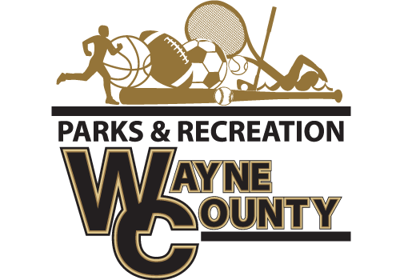
The Wayne County Recreation Department is accepting shirt bids on Soccer, Flag Football and Cheer jerseys for the 2018 season.
Soccer Requirements
-Brand Augusta dry fit or similar brand.
-Must be able to get all colors
-Must have all sizes available Youth Extra Small to Adult XXL
-Print Sponsor on back, Logo on left chest, and number on right chest.
Approximate Numbers for all leagues: 525
Flag Football Requirement
-Football Style Jersey
-Must be able to get all colors
-Must be able to get all sizes from youth extra small to Adult XXXL
Approximate Numbers for Flag: 108
Cheer Shirts.
1-Powder puff jersey with stripe 1-color print on front of team name
Approximate Number for Cheer : 185

Bids must be submitted before 2:00pm on August 31, 2018. Bids will be opened at that time. Winning bids will be awarded before 5:00pm on August 31, 2018. Delivery date on all uniforms must be by Friday September 21, 2018. Bids must be delivered to Wayne County Commissioner’s office at 341 E Walnut Street, Jesup GA, 31546 or mailed to PO Box 270, Jesup GA, 31598 Attn: Amanda Hannah, envelopes must be marked Wayne County Recreation “BID”. Wayne County reserves the right to reject any and all bids with or without cause, to waive any informality in a bid, and to make awards in the interest of Wayne County.

