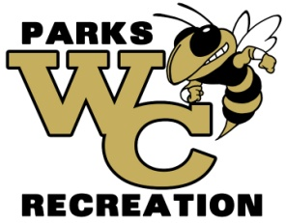
The Wayne Recreation office is accepting shirt bids for fall 2023
(Cheer, Soccer and Flag Football)
Soccer Requirements
-Brand-Augusta dry fit or similar brand.
-Must be able to get all colors.
-Must have all sizes (YXS-AXXL)
-Sponsor print on back, Logo on left chest, and number on right chest
Flag Football Requirement
-Football style Jersey
-Must be able to get all colors
-Must be able to get all sizes (YXS-AXXL)
Cheer Shirts
-Brand-Augusta dry fit or similar brand
-Must be able to get all colors
-Must have all sizes (YXS-AXXL)
-Team name on front

Bid must be submitted before 12:00 pm on August 23, 2023. Bids will be opened at that time. Winning bids will be awarded by 5:00 pm on or before Thursday, August 24, 2023. Bids must be delivered to Wayne County Commissioner’s office at 341 E Walnut Street, Jesup GA 31546 or mailed to PO Box 270, Jesup GA 31598 Attn: Amanda Hannah, envelopes must be marked WAYNE COUNTY RECREATION BID. Wayne County reserves the right to reject any and all bids with or without cause, to waive any informality in a bid, and to make awards in the interest of Wayne County.

