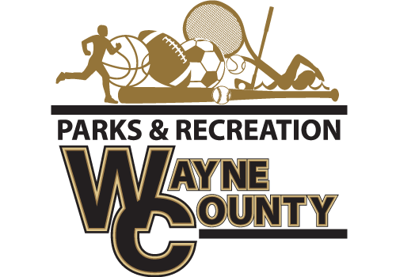
400 Hinson Mosley Road, Jesup Ga 31545
Phone: 912-427-5915
Fax: 912-427-5945
Recreation Director: Speck Echols

The Wayne County Recreation Department is accepting bids for 2021-2022 Basketball Jerseys.
Requirements
-Mesh Tank Top Reversible Jersey
-Must have all sizes available Youth to Adult XXL
Approximate Numbers for all leagues: 300
Coaches Shirt Requirement
Approximate Number for coaches/assistant: 50
-Augusta dri-fit brand-shirt with team name on front
Bids must be submitted before 10:00 am on Monday, December 27, 2021. Bids will be opened at that time. Winning bids will be awarded before 5:00 pm on December 28, 2021. Delivery date on all uniforms must be by Friday, January 14, 2022.
Bids must be delivered to Wayne County Commissioner’s office at 341 E Walnut Street, Jesup, Georgia 31546 or mailed to PO Box 270, Jesup, Georgia 31598 Attn: Amanda Hannah, envelopes must be marked Wayne County Recreation “BID”. Wayne County reserves the right to reject any and all bids with or without cause, to waive any informality in a bid, and to make awards in the interest of Wayne County.

