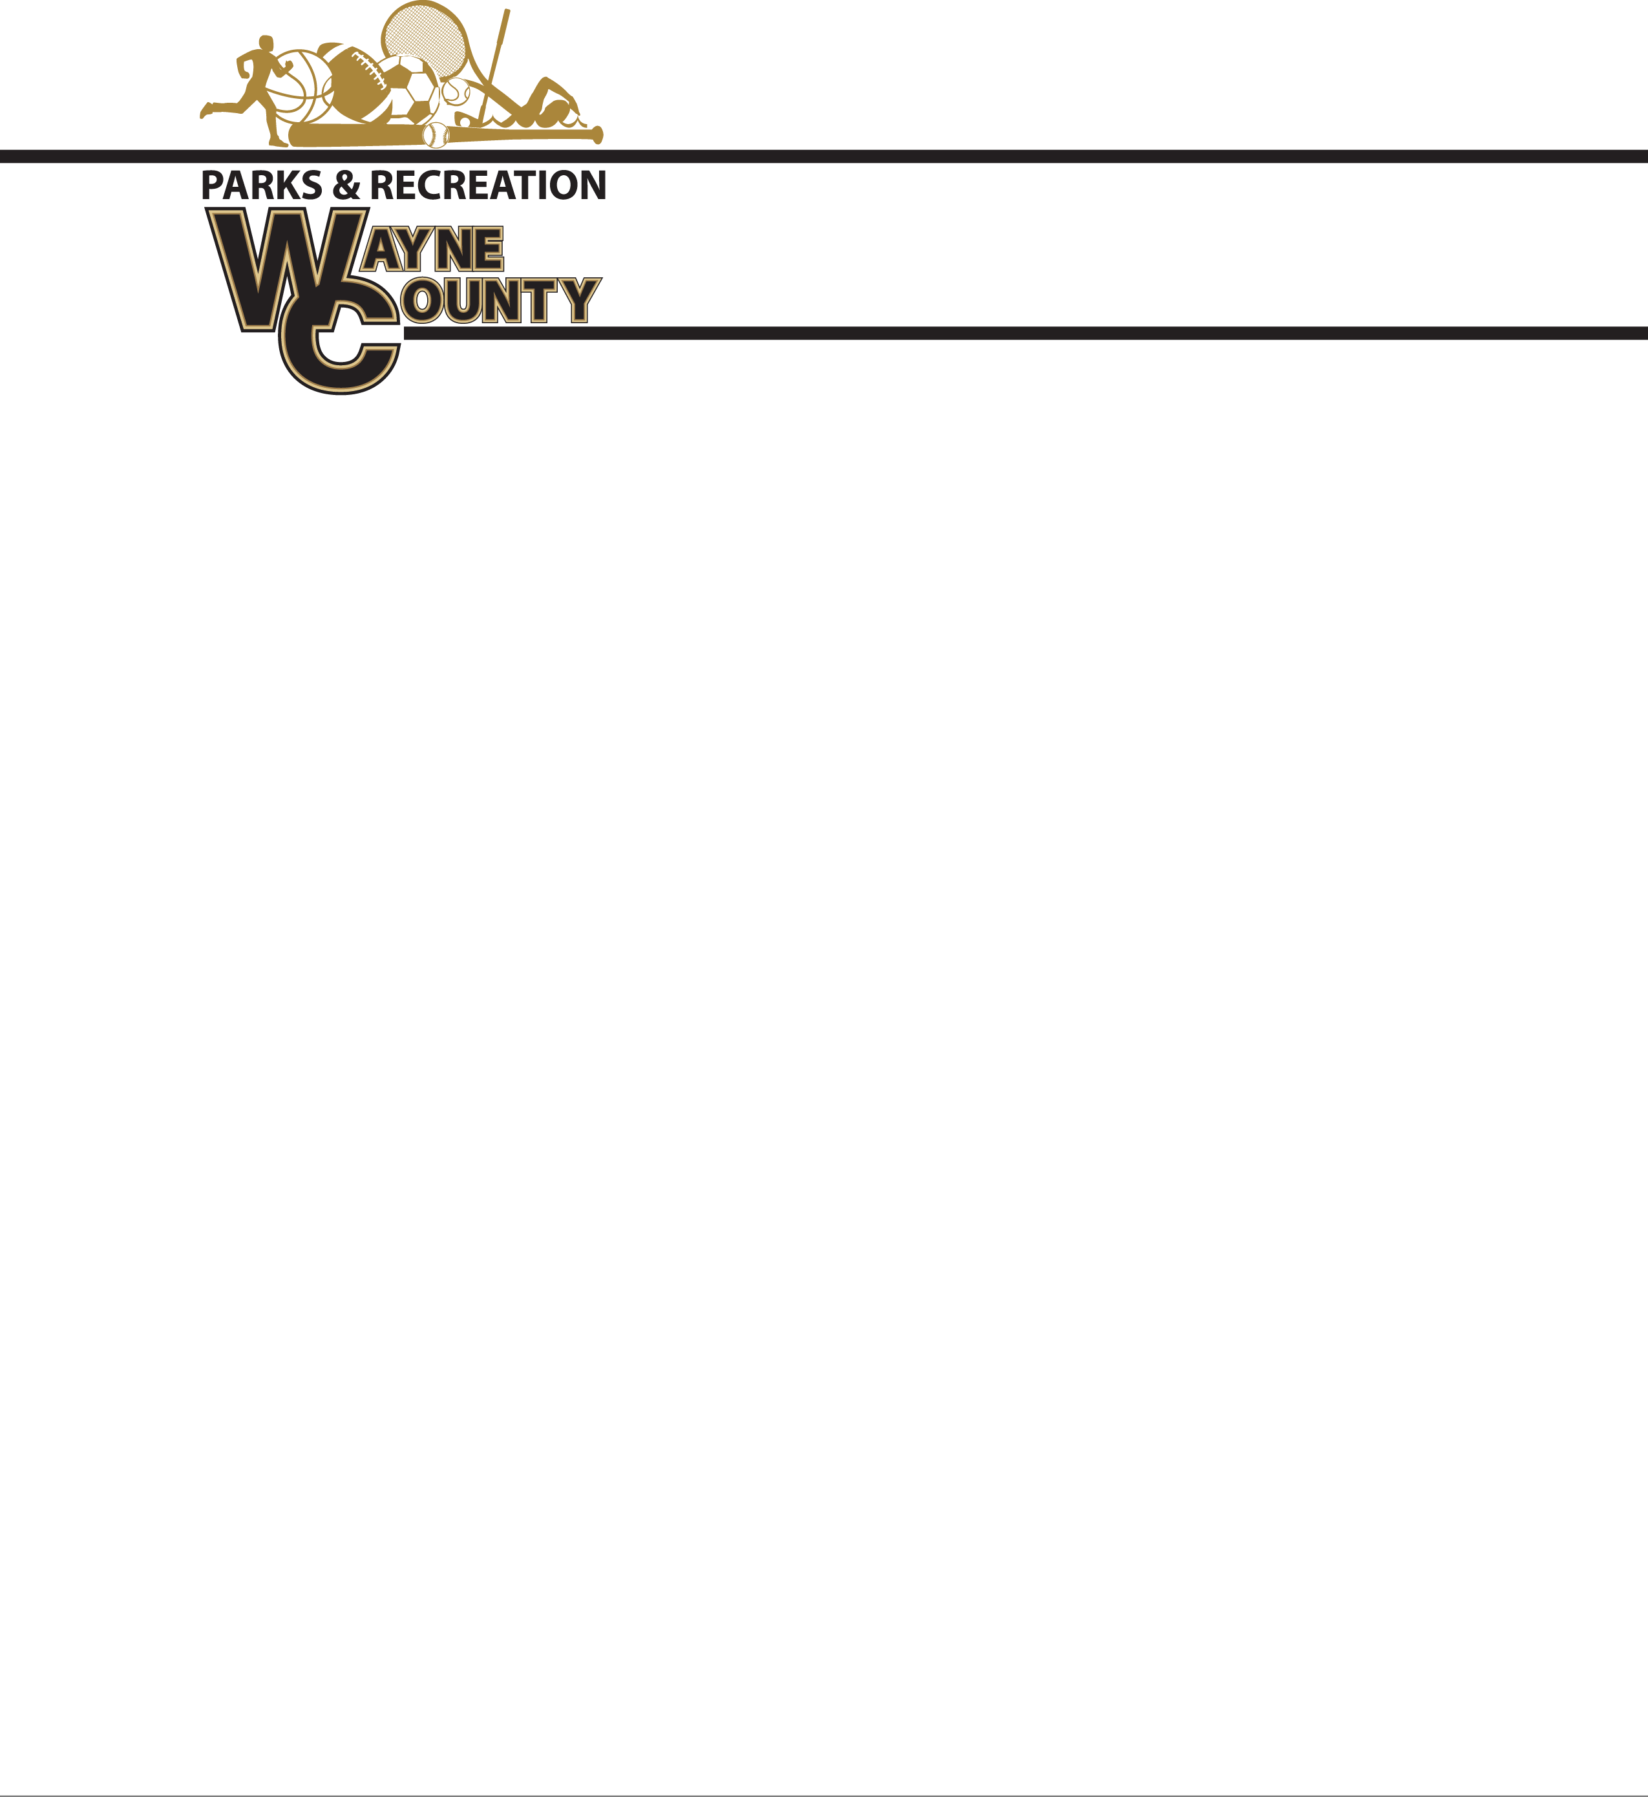

**Spring Baseball Shirt and Hat Bid**

MLB replica jersey shirts are Majestic 100 % Cotton MLB replica Jersey with matching hat.

6” number pressed on back

Sponsor will be on back of shirt (Above and if needed below number)

Approximately 850 Youth Shirts and Hats $____________

Approximately 200 Adult Shirts and hats $_____________

C**oaches Shirts Replica MLB Replica with sponsor on back:**

Approximately 50 Coaches shirts and hats: $____________

Company Name:__________________________

Signature________________________________ Date_______________________________

Bids must be submitted before Noon Thursday, February 28, 2019. Bids will be opened at that time. Winning bids awarded before 5:00 pm. Delivery date on all uniforms/hats will be April 5, 2019 at Noon.

Bids may be taken to Commissioners Office at 341 E Walnut St. ATTN: Amanda Hannah, envelopes must be marked Wayne County Recreation “BID”. Wayne County reserves the right to refuse any bid submitted.