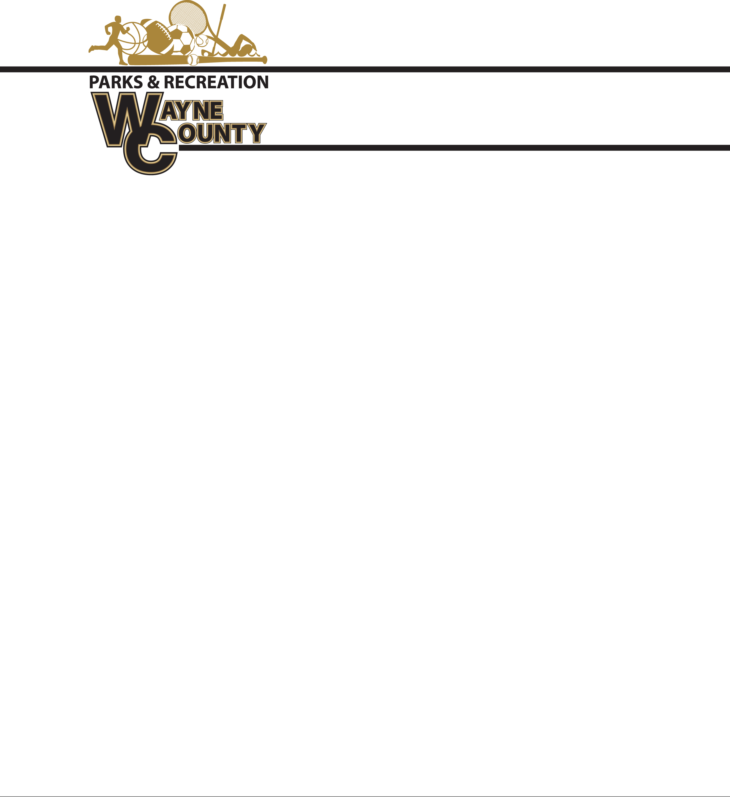

**Spring Baseball Shirt and Hat Bid**

MLB replica jersey shirts are 100 % Cotton MLB replica Jersey with matching hat or a Dri-fit replica jersey shirt and hat.

6” number pressed on back

Sponsor will be on back of shirt (Above and if needed below number)

Approximately 850 Youth Shirts and Hats $____________

Approximately 200 Adult Shirts and hats $_____________

**Coaches Shirts Replica MLB Replica with sponsor on back:**

Approximately 50 Coaches shirts and hats: $____________

Please specify if Cotton or Dri-fit: _________________________

Company Name:________________________________________

Signature________________________________ Date_______________________________

Bids must be submitted before Noon Friday, February 25, 2022. Bids will be opened at that time. Winning bids awarded before 5:00 pm. Delivery date on all uniforms/hats will be March 22, 2022 at Noon.

Bids may be taken to Commissioners Office at 341 E Walnut St. ATTN: Amanda Hannah, envelopes must be marked Wayne County Recreation “BID”. Wayne County reserves the right to refuse any bid submitted.