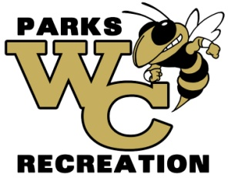**The Wayne Recreation office is accepting shirt bids for fall 2025**

**(Cheer, Soccer, Football, and Flag Football)**

**Soccer Requirements**

-Brand-Augusta dry fit or similar brand.

-Must be able to get all colors.

-Must have all sizes (YXS-AXXL)

-Sponsor print on back, Logo on left chest, and number on right chest

**Football Requirement**

-Football style Jersey

-Must be able to get all colors

-Must be able to get all sizes (YXS-AXXL)

**Flag Football Requirement**

- Augusta dry fit or similar brand

- Must be able to get all colors

- Must be able to get all sizes (YXS-AXXL)

**Cheer Shirts**

-Brand-Augusta dry fit or similar brand

-Must be able to get all colors

-Must have all sizes (YXS-AXXL)

-Team name on front

Bid must be submitted before 12:00 pm on Wednesday, July 16, 2025. Bids will be opened at that time. The winning bids will be awarded by 5:00 pm on or before Thursday, July 17, 2025. Bids must be delivered to Wayne County Commissioner’s office at 341 East Walnut Street, Jesup GA 31546 or mailed to PO Box 270, Jesup GA 31598 Attn: Amanda Hannah, envelopes must be marked WAYNE COUNTY RECREATION BID. Wayne County reserves the right to reject any and all bids with or without cause, to waive any informality in a bid, and to make awards in the interest of Wayne County.