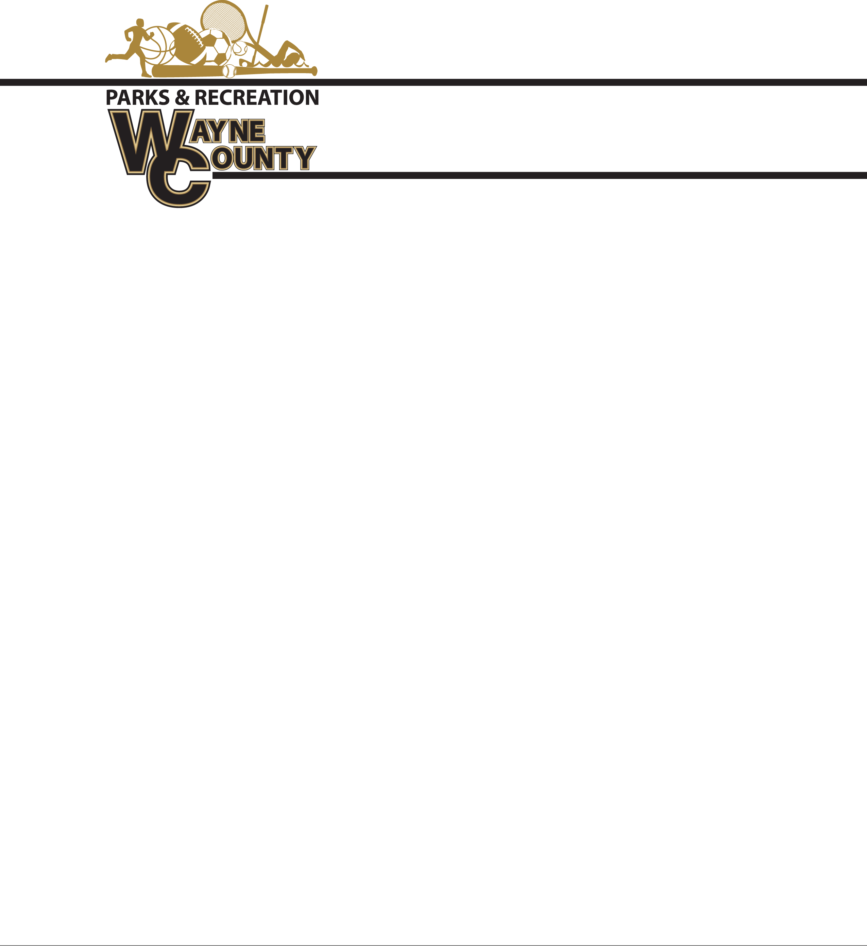

**Spring Baseball Shirt and Hat Bid**

Shirts are Majestic 100% Cotton

One color 6” number pressed on back

Sponsor will be on back of shirt (Above and if needed below number)

Youth Shirts – $________

Adult Shirts –Total $________

**Coaches Shirts Replica MLB 100% Cotton Shirt w/ sponsor on back:**

Adult Small – AXL / Total $_____________

**2XL** - $__________________ **3XL**- $__________________

**\*Replica Hat Bid**

Boys Replica – MLB -$_________

----------------------------------------------------------------------------------------------------------------------------------------------

100% Cotton V Neck Sleeveless Shirt

One Color 6” number on back with Sponsor (Above and if needed below number)

Youth Shirts – $________ (*Youth Extra Small, Youth Small, Youth Medium, Youth Large)*

Adult Shirts –Total $________

**Coaches Shirts -100% Cotton Shirt w/ sponsor on back:**

Adult Small – AXL / Total $_____________

**2XL** - $__________________ **3XL**- $__________________

**\*Girls Visor Must Match Uniform:**

Girl’s visor: $___________

-----------------------------------------------------------------------------------------------------------------------------------------------

**100% Cotton T-Shirts:** Team Name Printed on Front 2 color: One Color 6” number on back with Sponsor

Youth Shirts – $________ *(Youth Extra Small, Youth Small, Youth Medium, Youth Large)*

Adult Shirts –Total $________

**Coaches Shirts -100% Cotton T-Shirt w/ sponsor on back:**

Adult Small – AXL / Total $_____________

2XL - $__________________

3XL- $__________________

**Hat/Visor Must Match Uniform:**

Hats: $___________ Visor: $___________

Signature________________________________ Date_______________________________

Bids must be submitted before Noon Friday, March 2, 2018. Bids will be opened at that time. Winning bids awarded before 5:00 pm. Delivery date on all uniforms/Hats will be April 5, 2018 at Noon.

**Bids may be taken or mailed to The Commissioner’s Office at 341 E Walnut St. Jesup GA 31546.**

ATTN: Amanda Hannah, envelopes must be marked Wayne County Recreation “BID”. Wayne County reserves the right to refuse any bid submitted